Operating the G-90 Controls

Power On/Off 
In the Off state，momentarily press it to boot. In the On
state，press and hold it to shut down.

Volume Control 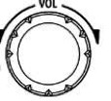
Speaker mode：Rotate the volume knob left or right to adjust the speaker output volume.
Headphone mode：Short Press the volume / headphone mode knob to activate the switch and enter headphone output
mode. Rotate the volume knob left or right to adjust the headset volume.
VOX mode on / off： Press and hold the volume knob for 3- second to turn the VOX feature on or off.
When using the AF in/out Port of the ACC interface, set the relevant volume in the system menu not the Volume Control.

Operating frequency band selection

The G90's frequency range covers 0.5 to 30 MHz. Amateur frequencies within this range are divided into multiple bands, and band switching can be performed in a number of different ways.

Operation method:
Press the BAND’s < or > button，Switch to the next or previous operating band separately.

15

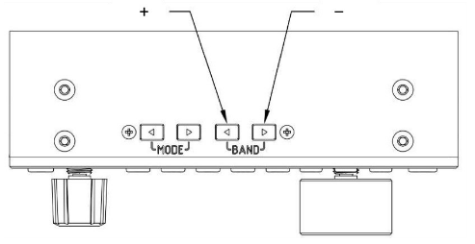

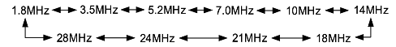

    - Each amateur band has a user-defined frequency that can be used temporarily, when the band is switched, you will see this custom band as a second band option. This can be confusing.
    - Whether the 60-meter band is usable depends on the laws of different countries (or regions).
    - Different versions of the machine have different frequency settings depending on the laws of that country (or regions).
    - VFO-A and VFO-B are two independent VFO modes that can be set to different operating frequencies and states. Check [VFO Settings] please.

Set the operating frequency
There are two ways to set the G90 operating frequency, first is to use the main knob (1hz thru 10Khz) and multi-function handle (100khz) to set the frequency.

Operating method 1：
Set the frequency using the main knob Main Knob

Short press the main knob, select 10 Hz, 100Hz,1kHz or 10kHz
step. 100KHz on MFK if defined.

Rotate the main knob to set the frequency using the current step.

Operating Method 2:

Set the frequency using the Microphone

Press the [F-INP ENT] button on the handle, G90 enter the frequency setting state, the cursor will blink in the first position on the left side of the frequency display bit;  Enter the frequency values you want to set, and then press the [F- INP ENT] button again to complete the frequency setting.
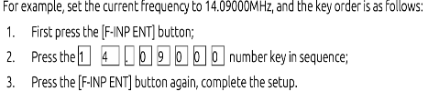

Operating mode select
Pressing [ MODE < - > ] button，will change the mode according to the following fixed order switching.

17

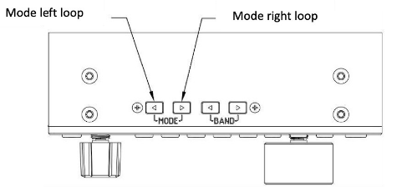

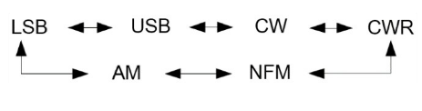

The FM mode can only be turned on when used with the GSOC controller.

Multi-function Knob Operation

Default: Steps by 100 kHz frequency bits.

Change Multi-function Knob operation via 2nd Feature use (without Function button press):

Short press: Enter SQL item to adjust SQL noise depth. 2nd short press to exit SQL.
Long press：To go to the User Custom Feature
menu, then rotate the main knob to select the

appropriate 2nd function: FFT scale, Freq Step 100k, SQL level, PO level or Key speed and assign to the MFK, and short press the “CMP”

key to Save the setting and ensure that the feature is selected. At this point, the feature is saved to the multifunction adjustment knob, turning the MFK will change the selected setting.

To exit the Long Press press the AGC button 

Adjust Transmitting Power Out

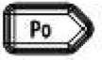
Operation method：
    - Short press the [Po] butt to enter the power setting state, the right side of the screen function display area will display the power settings number.
Rotate Main Knob for power setting with stepping of 1W PO, press
Main Knob to save.

19

When using the G90 transceiver for the first time without knowing the current antenna state, minimize the set transmit power value before Tuning
When the User Custom Feature of the Multifunction Knob is set to Power Out, turning the MFK will change Power out directly. Otherwise Po and VFO knob set power out

Split VFO Mode

There are two independent VFOs inside the G90 transceiver. We can set different frequencies and modes separately. With the SPL function, it is convenient to realize the split transceiver operation.
To Selelct VFO
1、 Press the [A/B / A>B] button to switch VFO operation between VFO-A and VFO-B.
2、 When switching to a certain VFO state, you can set
the current VFO's operating frequency, mode and other settings as needed.

Split frequency transceiver SPL operation method:
1、 Set the receiving frequency and mode (VFO-A) first;
2、 Then set the transmit frequency and mode (VFO- B)
3 、 Press Function Button so function lamp is on, of then Press [AGC/SPL] button. Press Function button to
begin Split Mode of transmission

4、 Turning on the SPL function to turns on the split transceiver mode.
You can make full use of VFOA/B to set different frequencies or modes, and switch between two frequency points in real time.

You may store this functionality into any Channel Memory, making SPL operation on a desired band very easy to access.

Automatic Antenna Tuning Unit (ATU) Operation

This G90 is integrated with an efficient automatic antenna tuner that can help you quickly set up and debug your antenna.
Before attempting to transmit or TUNE on any band, minimize the Power Output to prevent damage to the unit

Short press the [TUNE] button, the unit will be connected to the built- in antenna tuner and the "TUNE" logo will appear at the top of the screen.

21

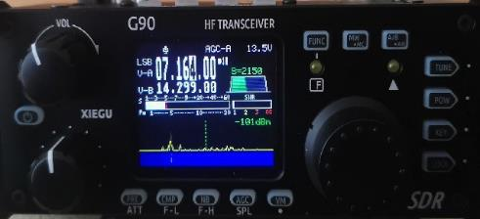

Next press the [TUNE] button again for 1 seconds and the ATU auto- tuning function will be activated. The unit will automatically return to receive status when tuning is complete.

Note：
- Press the [TUNE] button and the antenna icon appears at the top of the screen to indicate that the automatic antenna tuner function is turned on. You just turned on the automatic Antenna tuner but tuning has not been started.
- To use the built-in automatic antenna tuner, you must press tune again.

- If you start the transmission after pressing [TUNE] once, the “SWR” icon will appear on the top of the screen and flash, which means the standing wave of the current antenna is not tuned yet and needs to be retuned.
- When the antenna tunes to the current band, be sure to turn off the Automatic Antenna tuner feature by pressing [TUNE].
- When using a whip antenna and turning on the built-in antenna tuner for tuning, it is possible to cause strong RF interference to the unit or nearby electronic devices.

Scanning SWR

G90 host has an antenna standing wave scanning function, which can scan the standing wave parameters of the current

antenna, and is convenient for the user to adjust the antenna.。Operation method ：
1、 Long Press the [Po] button to start the standing wave scan;
2、 After the scan is completed, the scanning process is
automatically exited or you may Press [VM] button to stop the scan

